Ex. No. 9 | PDF AUTOMATION IN UI PATH
Date of Exercise | 12/03/2026

AIM
To automate the process of reading pdf text using UI Path Studio.
DESCRIPTION
This experiment demonstrates how to automate the process of reading and extracting text from a PDF file using UiPath Studio. In this workflow, the required PDF activities package is first installed to enable PDF handling. The automation then uses the Read PDF Text activity to extract text content from the entire document and store it in a variable. The extracted text is displayed using a Message Box for quick verification and is also saved into a text file using the Write Text File activity for future use. This process eliminates the need for manual reading and copying of PDF content, making it faster and more efficient. Overall, the experiment highlights how UiPath can be used to handle document processing tasks, improve productivity, and ensure accurate extraction of data from PDF files.
PROCEDURE:
Step 1: Open UiPath studio and click process to start a new project.
Step 2: Create a new blank process by giving a name and give create.
Step 3: Click Open main workflow.
Step 4: You will get the main workflow.
Step 5: Go to manage entities, chose all packages and search pdf extension of UI Path. Click that file to install and save.
Step 6: Create a new flowchart and name it as pdf read text.
Step 7: Add sequence to flowchart.
Step 8: From activities chose Read pdf text and drop it. Double click inside to upload the pdf document. In properties give the range as “All” and in output text as output.
Step 9: Chose message box from activities. Double click inside to type as output.
Step 10: Chose write text file from activities. Double click inside to type as output in text and save the file.
Step 11: Save and run the program.
OUTPUT:
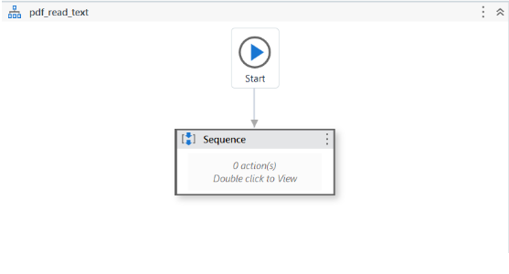

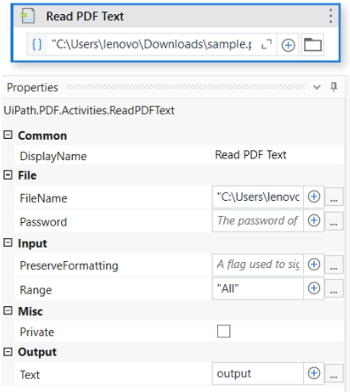
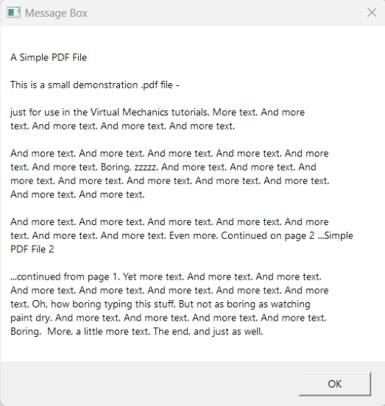

Result:
Thus, the process of reading pdf text using UI Path Studio is completed successfully.

